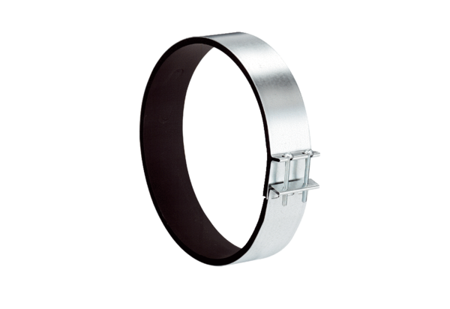Fixing cuff ELR 31Packing unit: 1 pieceRange: C
Article number: 0092.0114Manufacturer: MAICO

