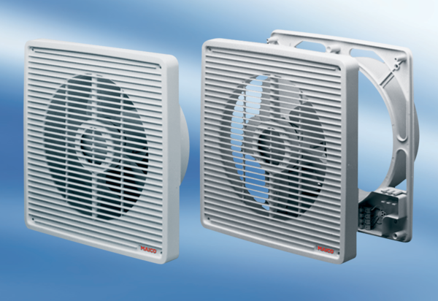Wall-mounted fan ETR 20Packing unit: 1 pieceRange: C
Article number: 0081.0504Manufacturer: MAICO

