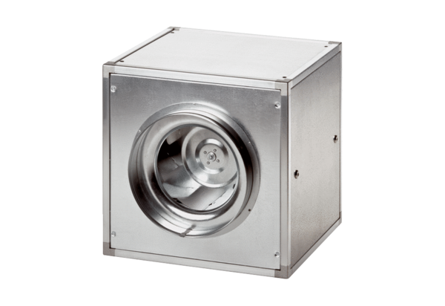Quickbox DSQ 31/4Packing unit: 1 pieceRange: C
Article number: 0080.0033Manufacturer: MAICO

