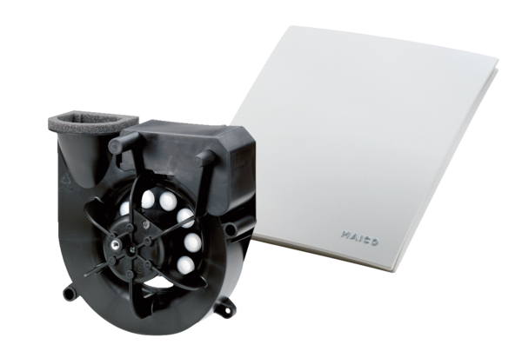Exhaust air element Centro-MPacking unit: 1 pieceRange: B
Article number: 0084.0182Manufacturer: MAICO

