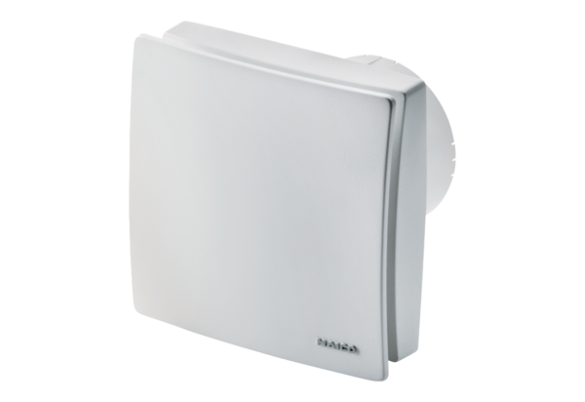Small room fan ECA 100 ipro RCHPacking unit: 1 pieceRange: A
Article number: 0084.0211Manufacturer: MAICO

