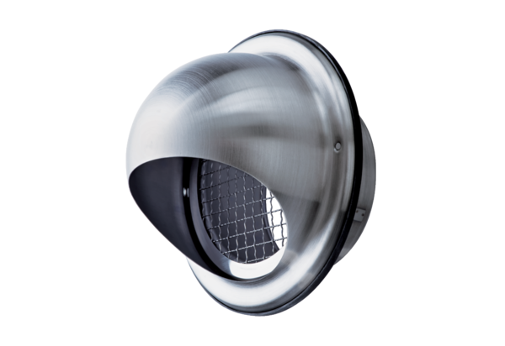Stainless steel cowl LH-V2A 12Packing unit: 1 pieceRange: C
Article number: 0151.0378Manufacturer: MAICO

