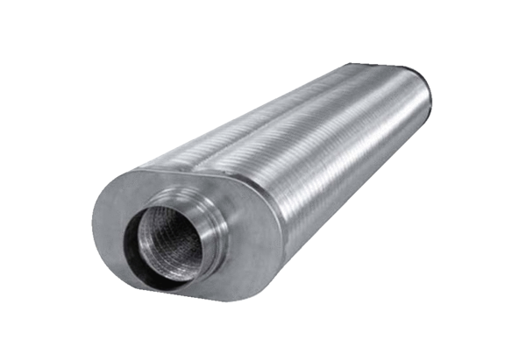Flat oval duct sound absorber RSOF 12/50Packing unit: 1 pieceRange: K
Article number: 0092.0531Manufacturer: MAICO

