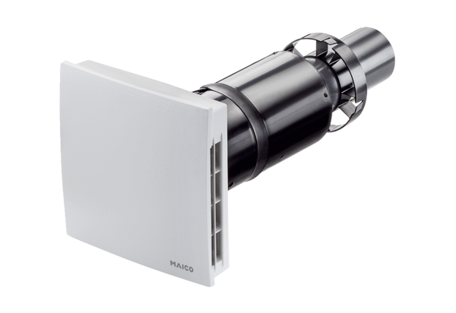Final assembly kit PPB 30 RCPacking unit: 1 pieceRange: K
Article number: 0095.0244Manufacturer: MAICO

