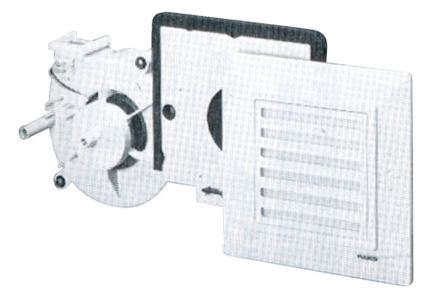Fan insert ER 17 VZPacking unit: 1 pieceRange:
Article number: 0080.0236Manufacturer: MAICO

