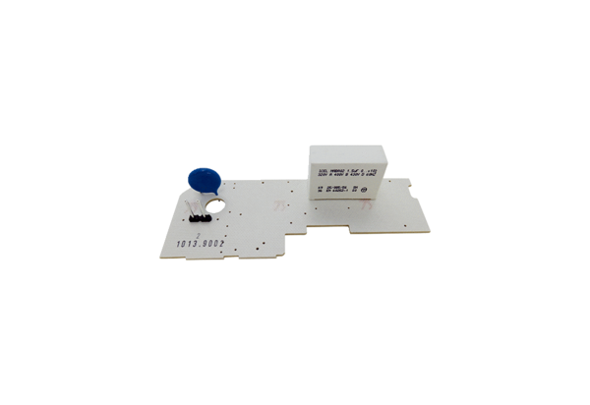Circuit board PL ER 100Range: B
Article number: E101.1013.9002Manufacturer: MAICO

