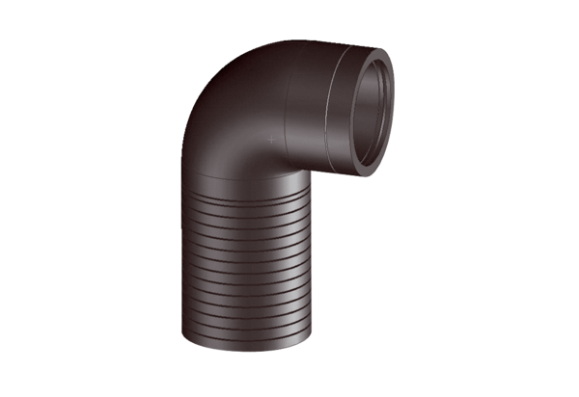Thermally insulated long pipe elbow ABLS 160Packing unit: 1 pieceRange: K
Article number: 0058.0048Manufacturer: MAICO

