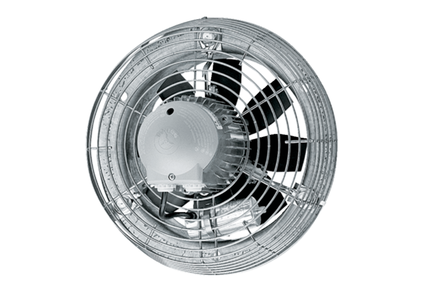Axial wall fan EZS 50/8 BPacking unit: 1 pieceRange: C
Article number: 0094.0010Manufacturer: MAICO

