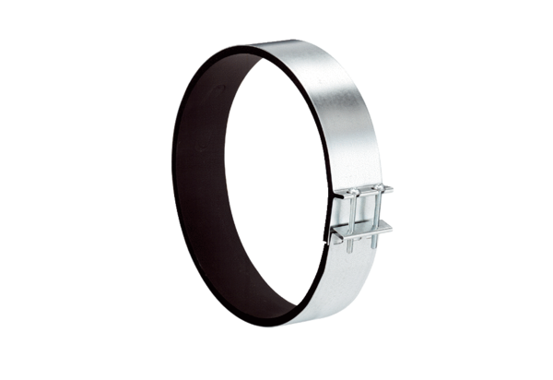Fixing cuff ELR 10Packing unit: 1 pieceRange: C
Article number: 0092.0109Manufacturer: MAICO

