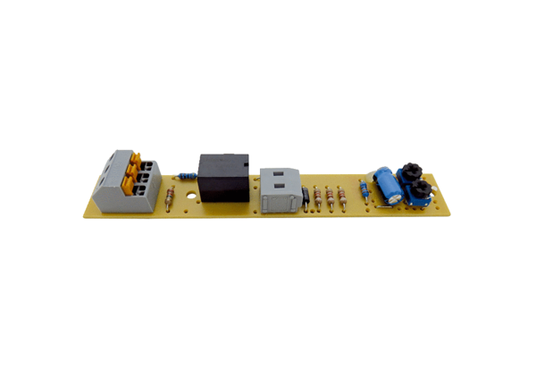Circuit board PL ECA 100 VZCRange: A
Article number: E101.1257.0000Manufacturer: MAICO

