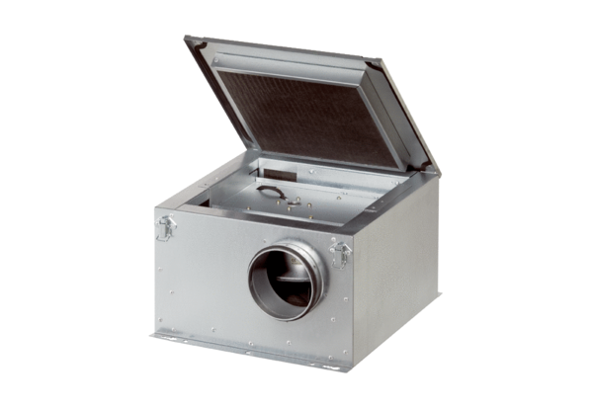Sound-insulated ventilation box ESR 16-2Packing unit: 1 pieceRange: C
Article number: 0080.0611Manufacturer: MAICO

