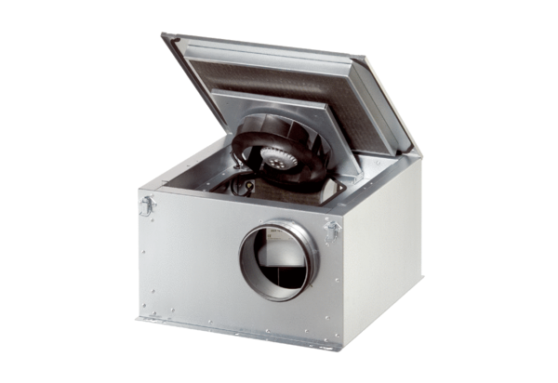Sound-insulated ventilation box ESR 25-2 SPacking unit: 1 pieceRange: C
Article number: 0080.0620Manufacturer: MAICO

