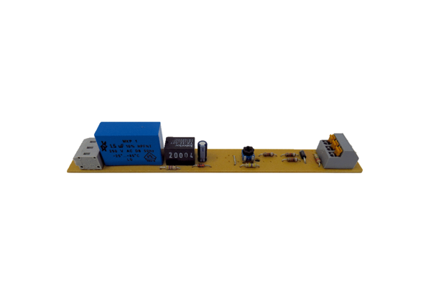Circuit board PL ECA 150 VZRange: A
Article number: E101.1250.0000Manufacturer: MAICO

