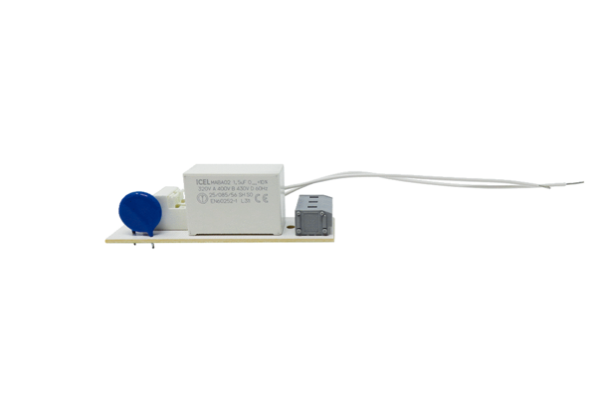Circuit board PL ECA 150 PRange: A
Article number: E101.1020.9100Manufacturer: MAICO

