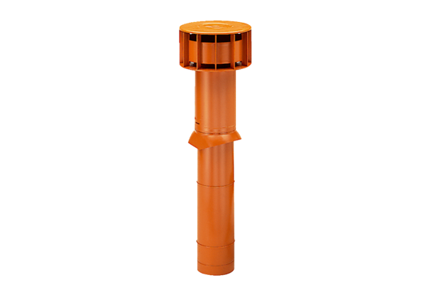Roof outlet DF 125 TPacking unit: 1 pieceRange: B
Article number: 0092.0373Manufacturer: MAICO

