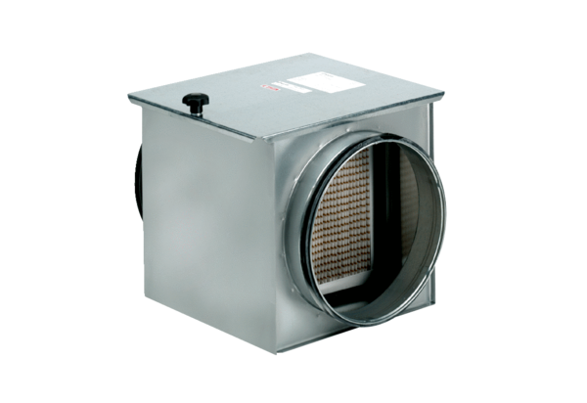Air filter TFE 12-5Packing unit: 1 pieceRange: C
Article number: 0149.0059Manufacturer: MAICO

