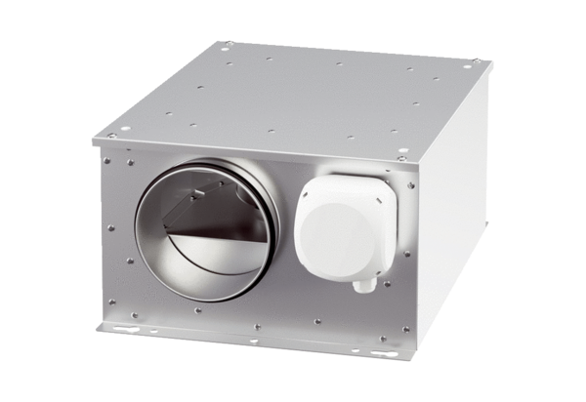Sound-insulated ventilation box ESR 12-3 ECPacking unit: 1 pieceRange: E
Article number: 0080.1000Manufacturer: MAICO

