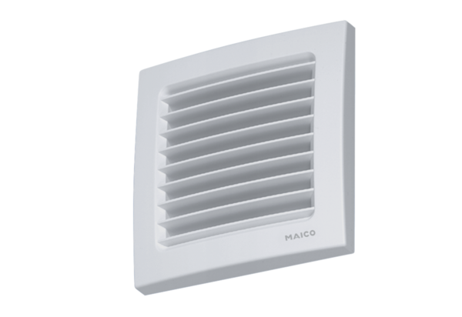Internal grille, adjustable AZE 100 PPacking unit: 1 pieceRange: K
Article number: 0059.0962Manufacturer: MAICO

