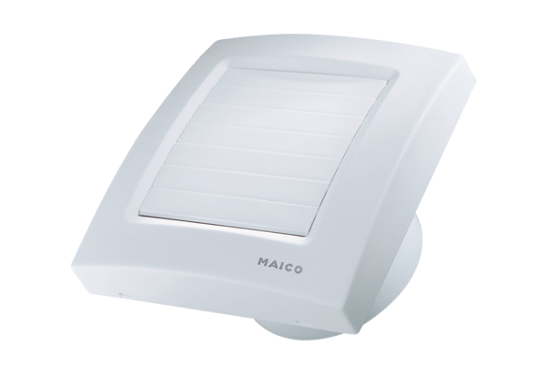Small room fan ECA 150 KVZPacking unit: 1 pieceRange: A
Article number: 0084.0016Manufacturer: MAICO

