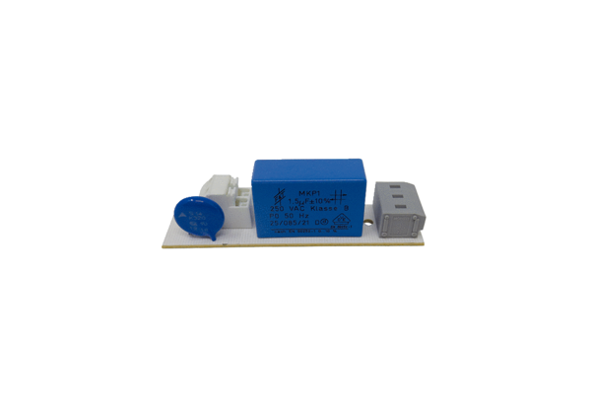Circuit board PL ECA 150Range: A
Article number: E101.1020.9001Manufacturer: MAICO

