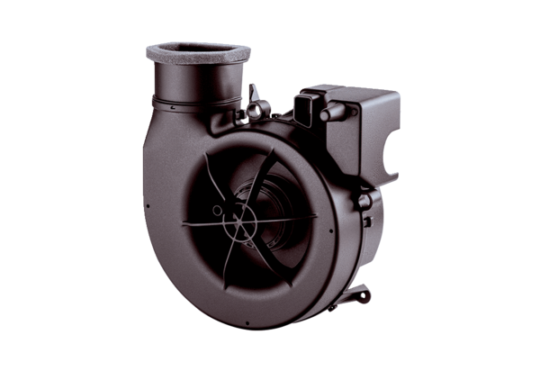Fan insert ER ECPacking unit: 1 pieceRange: B
Article number: 0084.0360Manufacturer: MAICO

