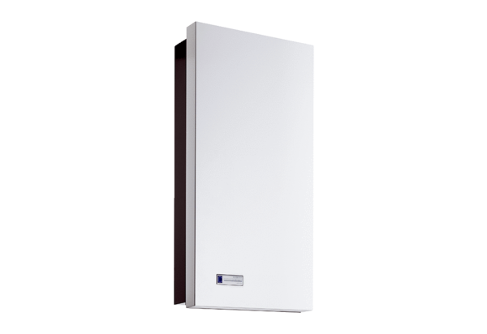installation kit Duo Z-SEPacking unit: 1 pieceRange: K
Article number: 0095.0331Manufacturer: MAICO

