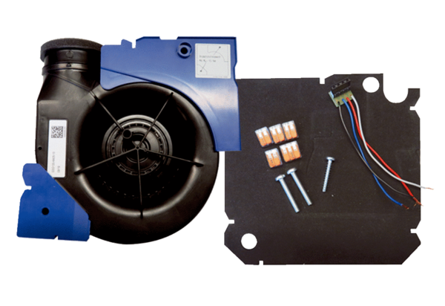Fan insert ER EC RF17Packing unit: 1 pieceRange: B
Article number: 0093.0614Manufacturer: MAICO

