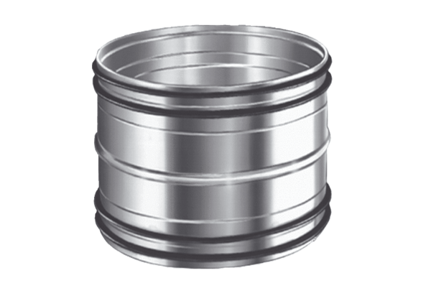Plug connectors for ducts SVR 100Packing unit: 1 pieceRange: K
Article number: 0055.0188Manufacturer: MAICO

