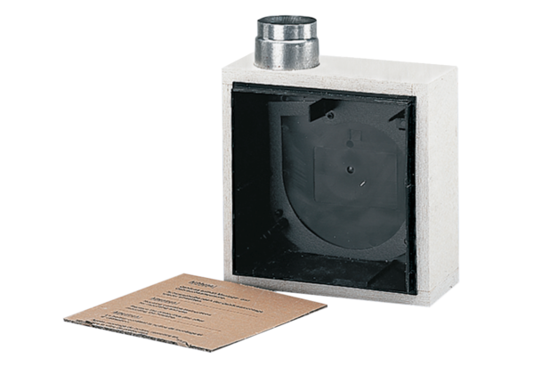Recessed-mounted housing ER - UPBPacking unit: 1 pieceRange: B
Article number: 0093.0968Manufacturer: MAICO

