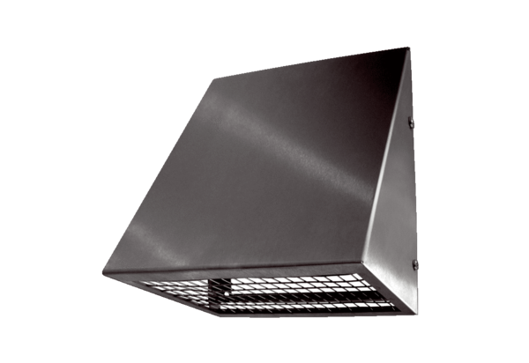Outside air wall connection KW-AL 16EPacking unit: 1 pieceRange: K
Article number: 0152.0077Manufacturer: MAICO

