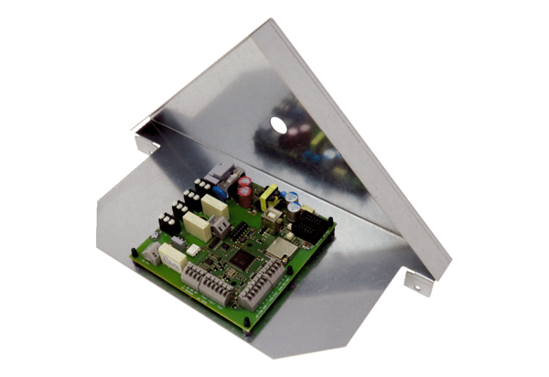Circuit board ST WS 75Range: K
Article number: E093.1610.0000Manufacturer: MAICO

