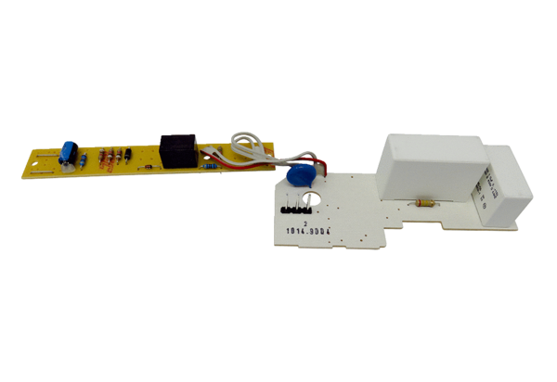Circuit board PL ER 60 VZRange: B
Article number: E101.1014.9004Manufacturer: MAICO

