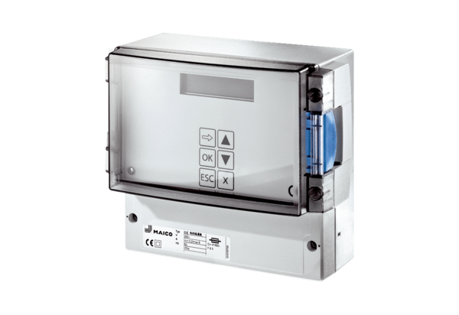Pressure and temperature control system EAT ECPacking unit: 1 pieceRange: E
Article number: 0157.0119Manufacturer: MAICO

