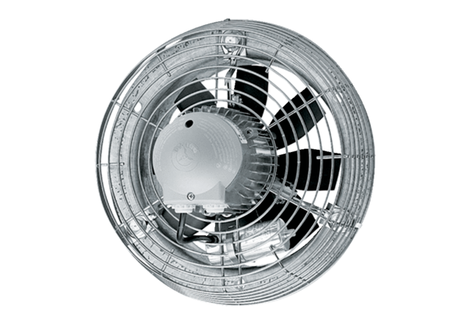Axial wall fan EZS 30/4 BPacking unit: 1 pieceRange: C
Article number: 0094.0003Manufacturer: MAICO

