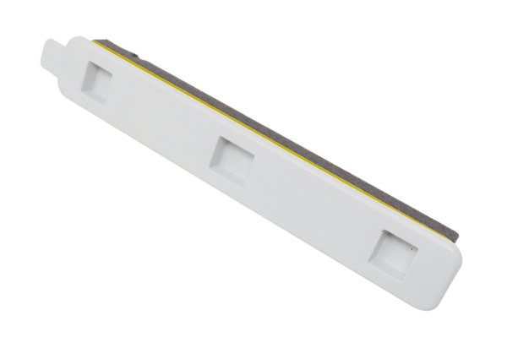Filter locking cover FA G4 WS 75Range: K
Article number: E175.0330.0000Manufacturer: MAICO

