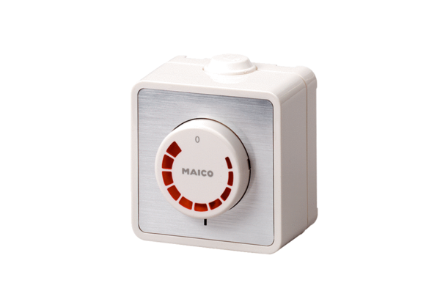Speed controller ST 2,5Packing unit: 1 pieceRange: C
Article number: 0157.0811Manufacturer: MAICO

