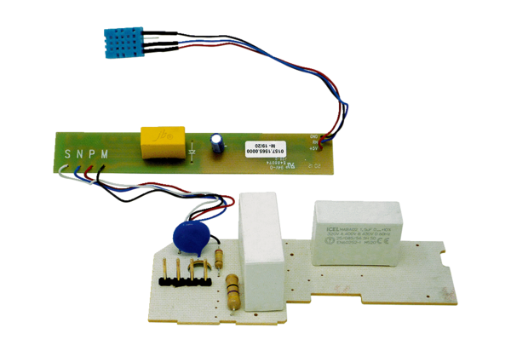Circuit board PL ER 100 HRange: B
Article number: E101.1015.9208Manufacturer: MAICO

