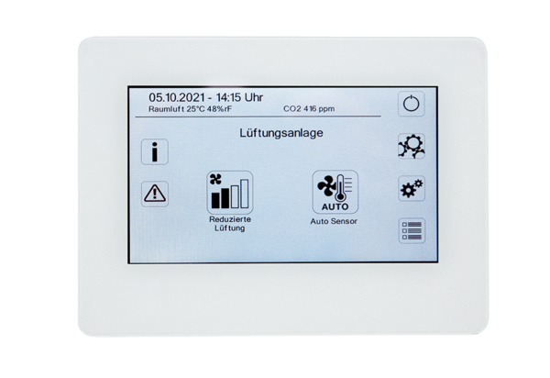Room air control RLS T2 WSPacking unit: 1 pieceRange: K
Article number: 0157.1656Manufacturer: MAICO

