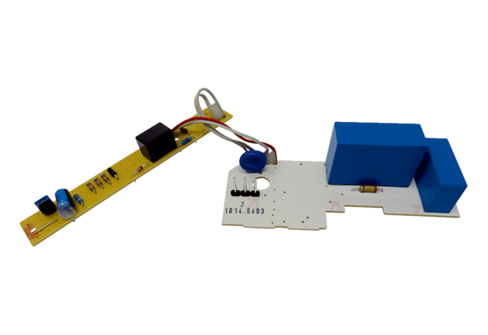Circuit board PL ER 60 IRange: B
Article number: E101.1014.9403Manufacturer: MAICO

