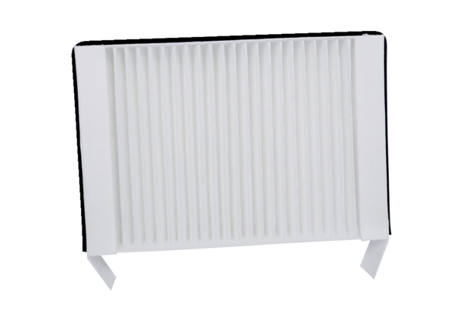Air filter, replacement WS 75 F7Packing unit: 1 pieceRange: K
Article number: 0093.1588Manufacturer: MAICO

