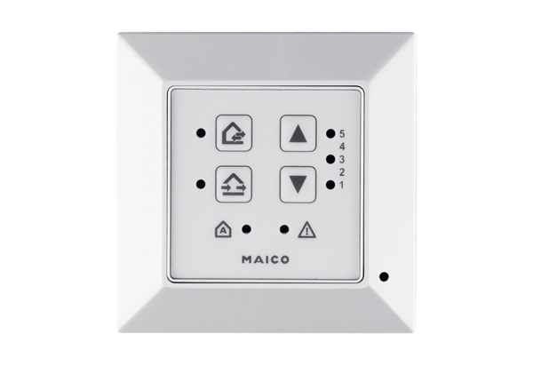Room air control RLS 45 KPacking unit: 1 pieceRange: K
Article number: 0157.0360Manufacturer: MAICO

