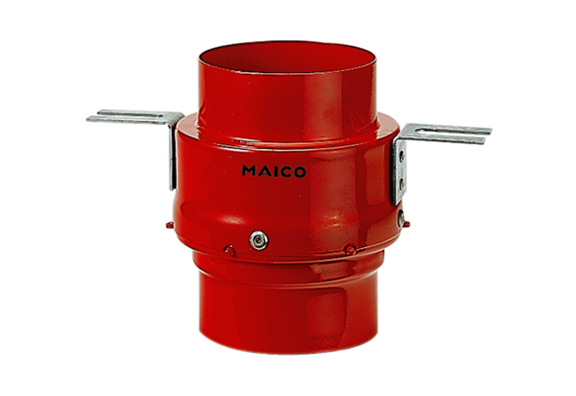Fire protection ceiling barrier TS 18 DN 160Packing unit: 1 pieceRange: B
Article number: 0151.0323Manufacturer: MAICO

