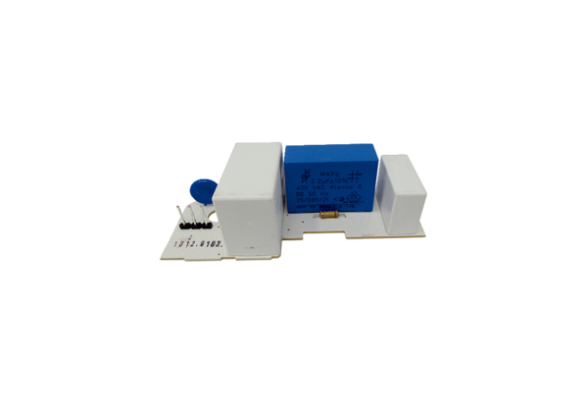Circuit board PL ER 60 GRange: B
Article number: E101.1012.9102Manufacturer: MAICO

