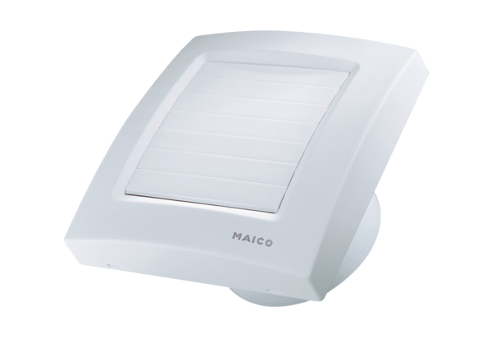Small room fan ECA 150 KPPacking unit: 1 pieceRange: A
Article number: 0084.0067Manufacturer: MAICO

