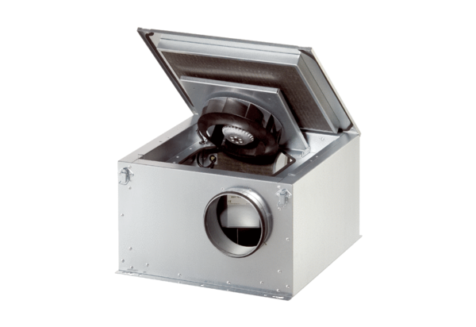Sound-insulated ventilation box ESR 12 ECPacking unit: 1 pieceRange: E
Article number: 0080.0084Manufacturer: MAICO

