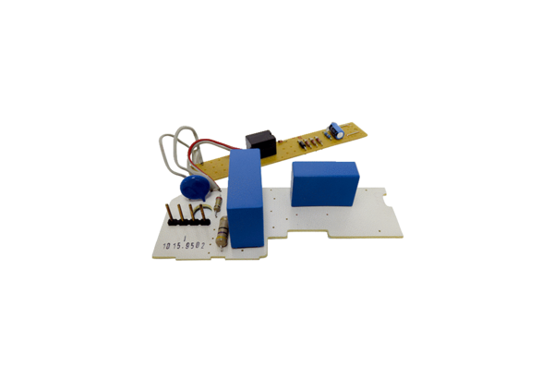Circuit board PL ER 100 GVZRange: B
Article number: E101.1015.9502Manufacturer: MAICO

