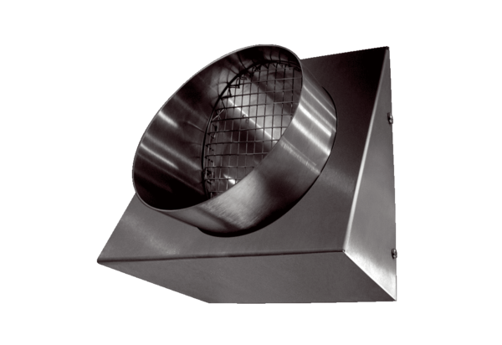Outgoing air wall connection KW-FL 16EPacking unit: 1 pieceRange: K
Article number: 0152.0079Manufacturer: MAICO

