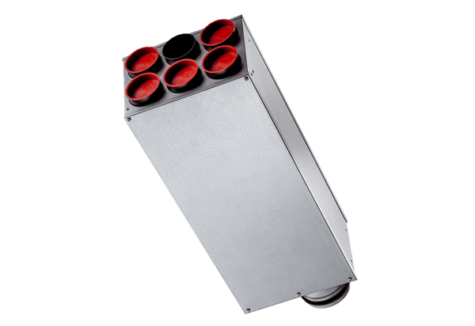Sound-insulation distributor SDV 125/6-75Packing unit: 1 pieceRange: K
Article number: 0092.0609Manufacturer: MAICO

