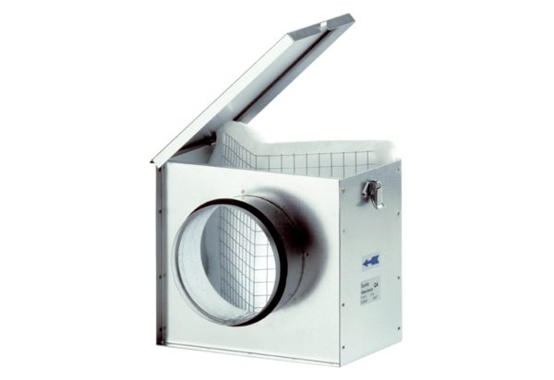Air filter TFE 12Packing unit: 1 pieceRange: C
Article number: 0149.0041Manufacturer: MAICO

