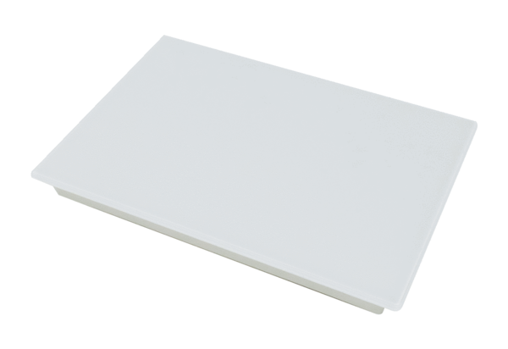Sealing kit RLS G1VPacking unit: 1 pieceRange: K
Article number: 0093.1591Manufacturer: MAICO

